# **Name: Abdurrahman Qureshi**

# **Roll No: 210451**

Practical No: 11N12

**1) Using various String Buffer Methods**

**CODE:**

class EXP11N12StringBufferTest{

public static void main(String args[]){

StringBuffer sb1=new StringBuffer(); //creates empty string

StringBuffer sb2=new StringBuffer("The Forbidden West");

StringBuffer sb3=new StringBuffer(25);

//length() System.out.println("\nLengths of the respective strings:\n");

System.out.println("Length of StringBuffer sb1: "+sb1.length());

System.out.println("Length of StringBuffer sb2: "+sb2.length());

System.out.println("Length of StringBuffer sb3: "+sb3.length());

//capacity

System.out.println("\nCapacity of the respective strings:\n");

System.out.println("Capacity of StringBuffer sb1: "+sb1.capacity());

System.out.println("Capacity of StringBuffer sb2: "+sb2.capacity());

System.out.println("Capacity of StringBuffer sb3: "+sb3.capacity());

//append

System.out.println("\nAppending string 3:\n");

sb3.append("Napolean");

System.out.println("StringBuffer sb3: "+sb3);

System.out.println("Length of StringBuffer sb3: "+sb3.length());

System.out.println("Capacity of StringBuffer sb3: "+sb3.capacity());

//reverse()

System.out.println("\nReversing String 2:\n");

sb2.reverse();

System.out.println("StringBuffer sb2 after reverse: "+sb2);

//delete

System.out.println("\nDeleting some part of string 2:\n");

sb2.delete(2,6);

System.out.println("StringBuffer sb2: "+sb2);

//substring(si) and substring(si,ei)

//insert()

System.out.println("\nInserting in string 2:\n");

sb3.insert(0, "C ");

System.out.println("StringBuffer sb3: "+sb3);

//replace()

System.out.println("\nReplacing in string 3:\n");

sb3.replace(2,6,"Bonaparte");

System.out.println("StringBuffer sb3: "+sb3); }}

**OUTPUT:**

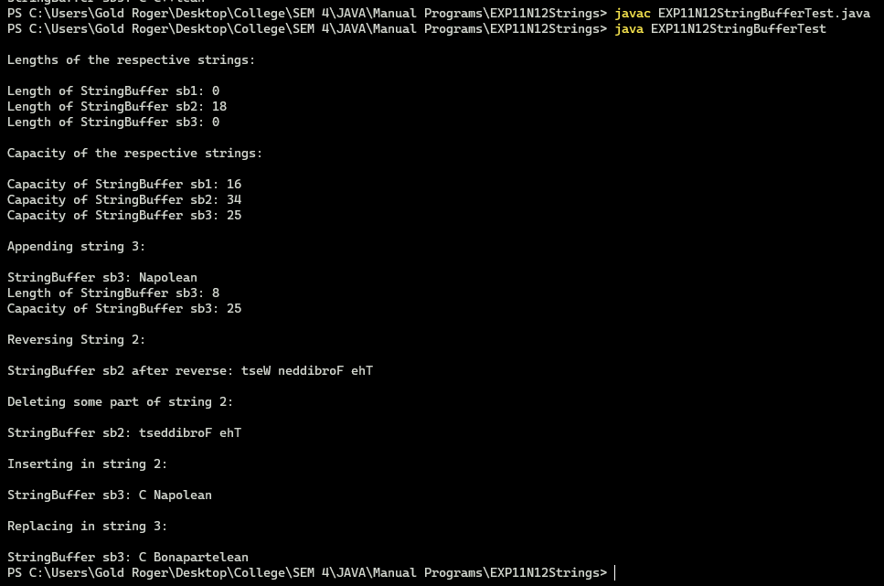

**2) Using Various String methods**

**CODE:**

class EXP11N12StringActivity{

static void StringMethods(){

String s1 = "Horizon"; String s2 = new String("Ghost Of Tsushima");

char[] ch = {'R','E','7'}; String s3 = new String(ch);

//charAt()

System.out.println("The character at index 4 in s2 is : " + s2.charAt(4));

//equals()

System.out.println("Are strings s1 and s2 equal with integers? ---> " + s1.compareTo(s2));

s2 = s1;

System.out.println("After copying s1 into s2 , are the strings s1 and s2 equal with integers? ---> " + s1.compareTo(s2));

//equals()

System.out.println("After copying - Are strings s1 and s2 equal? ---> " + s1.equals(s2));

s2 = ("Ghost Of Tsushima");

System.out.println("After copying OG value - Are strings s1 and s2 equal? ---> " + s1.equals(s2));

//equalsIgnoreCase()

s2 = s1;

System.out.println("Are strings s1 and s2 equal if we ignore thier casings? ---> " + s1.equalsIgnoreCase(s2));

s2 = ("Ghost Of Tsushima");

System.out.println("After copying OG value - Are strings s1 and s2 equal if we ignore thier casings? ---> " + s1.equalsIgnoreCase(s2));

//equals()

System.out.println("The length of string s3 is : " + s3.length());

System.out.println("The length of string s2 is : " + s2.length());

//replace()

System.out.println(s2);

System.out.println("Replacing \'S\' with \'$\' in String s2" + s2.replace("s","$"));

//startsWith()

System.out.println("Does string s3 start with \'R\'? " + s3.startsWith("R"));

System.out.println("Does string s3 start with \'h\'? " + s3.startsWith("h"));

//endsWith()

System.out.println("Does string s3 end with \'7\'? " + s3.endsWith("7"));

System.out.println("Does string s3 end with \'l\'? " + s3.endsWith("l"));

//indexOf()

System.out.println("First Index of \'o\' in string s1 : " + s1.indexOf("o"));

System.out.println("First Index of \'s\' in string s1 :" + s2.indexOf("s"));

//lastIndexOf()

System.out.println("Last Index of \'o\' in string s1 : " + s1.lastIndexOf("o"));

System.out.println("Last Index of \'s\' in string s1 :" + s2.lastIndexOf("s"));

//substring()

System.out.println("Substring of s2 from index 3 - 11 is : " + s2.substring(3 , 11)); }

public static void main(String[] args) {

StringMethods(); }}

**OUTPUT:**

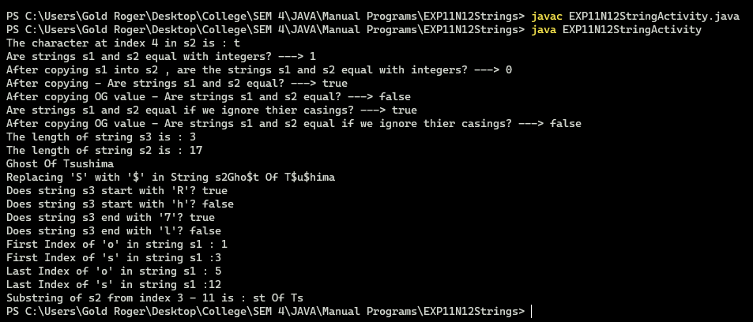

**3) Implement a program to accept a string from user and count all the occurrences of a particular word in the string.**

**CODE:**

public class EXP11N12WordOccurances {

public static void main(String args[]) {

String string = "The enemy of my enemy is my friend.";

String word = "enemy";

String temp[] = string.split(" ");

int count = 0;

for (int i = 0; i < temp.length; i++) {

if (word.equals(temp[i])) count++;}

System.out.println("\nThe string is: " + string);

System.out.println("The word " + word + " occurs " + count + " times in the above string\n");}}

**OUTPUT:**

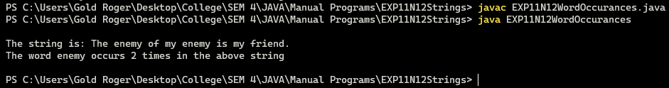

**4) Implement a program to accomplish the following task String/StringBuffer-class:**

* **Accept a password from user**
* **Check if password is correct then display “Good”**
* **else display “Incorrect Password”**
* **Append password with the string “Welcome to Java!!!”**
* **Display the password in reverse order**
* **Replace the character '!' in password with '*' character.**

**CODE:**

import java.io.*;

public class EXP11N12StringPassword {

public static void main(String[] args) throws IOException{

System.out.println("Enter the password");

BufferedReader br = new BufferedReader(new InputStreamReader(System.in));

StringBuffer pass = new StringBuffer(br.readLine());

if(pass.toString().equals("Stalin")){

System.out.println("Good");}

else

System.out.println("Incorrect Password");

System.out.println("Appended password " + pass.append("Stalin, Welcomes to the project"));

System.out.println("Reverse password is " + pass.reverse());

pass = new StringBuffer(pass.toString().replace("!", "$"));

System.out.println("Pass : " + pass); }}

**OUTPUT:**

